Introduction & Dataset Description:
The dataset employed in this project is the FC 26 (EA Sports FC 2026) Player Dataset, which has the specifics of player features, performance scores, financial data, and demographic data of professional football players in leagues worldwide. The dataset has been extensively employed in the sport analytics studies to evaluate players, predict their performance and in the exploration of data. The dataset is rich with player records, which makes it a good source to conduct data cleaning, exploration data analysis and machine learning-based prediction activities.
Dataset Reference: Kaggle. (2025). FC 26 Player Dataset. Kaggle. https://www.kaggle.com/datasets/rovnez/fc-26-fifa-26-player-data/data
Selected Attributes:
- short_name (Player Name): A character variable representing the short display name of the player.
- player_positions: A categorical variable indicating the playing position(s) of the player on the field.
- overall: Continuous numerical variable representing the player's current overall performance rating on a scale of 0–99.
- potential: Continuous numerical variable representing the player's maximum projected rating, reflecting future growth capacity.
- value_eur (Market Value in EUR): Continuous variable showing the estimated transfer market value of the player in Euros.
- wage_eur (Weekly Wage in EUR): Continuous variable indicating the player's weekly wage in Euros; higher wages typically reflect better performing players.
- age: Continuous numerical variable representing the player's age in years.
- height_cm (Height in cm): Continuous variable measuring the player's height in centimeters; relevant for position specific physical analysis.
- weight_kg (Weight in kg): Continuous variable measuring the player's body weight in kilograms; important for physical profiling.
- preferred_foot: Binary categorical variable indicating the player's dominant foot.
  - Right = Right footed
  - Left = Left footed
- pace: Continuous variable reflecting the player's speed attributes; commonly used in evaluating attackers and wing players.
- shooting: Continuous variable measuring the player's shooting ability; commonly used in forward player analysis.
- passing: Continuous variable representing the player's passing accuracy and vision; key for midfield evaluation.
- dribbling: Continuous variable measuring the player's ball control and dribbling skill; typically elevated in attacking players.
- defending: Continuous variable indicating the player's defensive capability; high values are typical for center backs and defensive midfielders.
- physic: Continuous variable showing total physical attributes including strength and stamina, reflecting the player's physical presence on the field.

Data Import and View
This will load the CSV file into R with correct column headers and delimiting settings and open it in the RStudio data viewer.
Code:

df <- read.csv("C:\\Users\\towhi\\Downloads\\archive (3)\\FC26_20250921.csv")

df <- df[, c("short_name", "player_positions", "overall", "potential",
"value_eur", "wage_eur", "age", "height_cm", "weight_kg",
"preferred_foot", "pace", "shooting", "passing",
"dribbling", "defending", "physic")]
view(df)

Output:
The output shows the dataset loaded successfully.

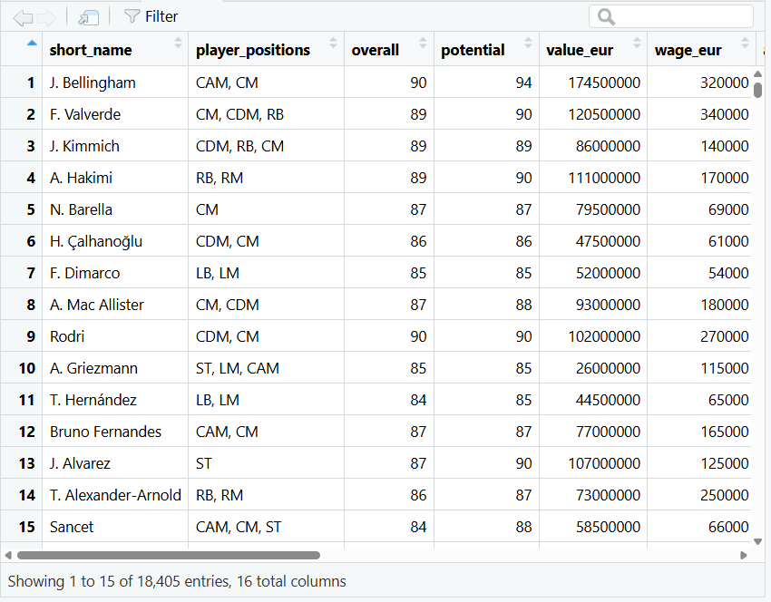
Dataset Dimensions:
Code:

cat("Number of rows:", nrow(data), "\n")
cat("Number of columns:", ncol(data))

Output:

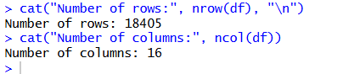

The output indicates that the dataset has 18,405 records of players and 110 columns that store different player attributes. There are too many columns (110) to analyze focusedly, and therefore, we will choose only 16 key variables that are pertinent to our project.

Dataset Structure:
Code:

str(df)

Output:
The str() function provides the internal structure of the dataframe. The output lists each variable name, its data type (character, numeric, factor), and example values.

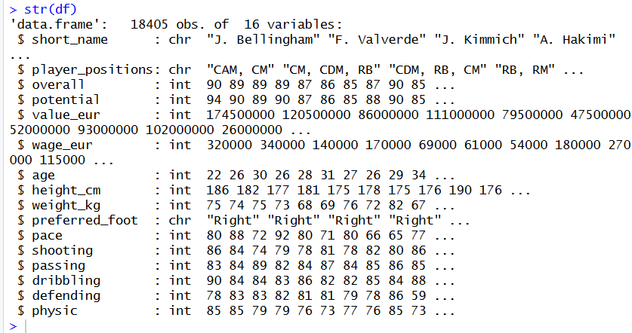

Introducing Intentional Data Issues:
The following code intentionally introduces missing values, noisy/invalid values, and extreme outliers into the dataset to simulate real world data challenges.
- Missing Values:

Code:

df$age[100] <- NA
df$height_cm[300] <- NA
df$weight_kg[400] <- NA
df$overall[500] <- NA
df$potential[800] <- NA

Output:

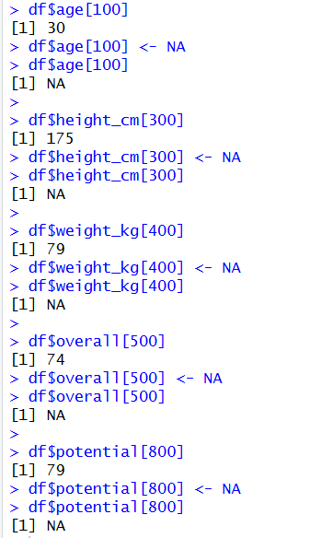

The output confirms that each value was successfully replaced with NA.

- Noisy or Invalid Values

Code:

df$age[350] <- 999
df$value_eur[8000] <- -99999
df$physic[1100] <- -10
df$preferred_foot[200] <- "Hand"
df$preferred_foot[3000] <- "none"
df$height_cm[450] <- 999
df$shooting[5500] <- -50
df$weight_kg[12000] <- -30
df$passing[7777] <- 999
df$age[16000] <- -12

Output:

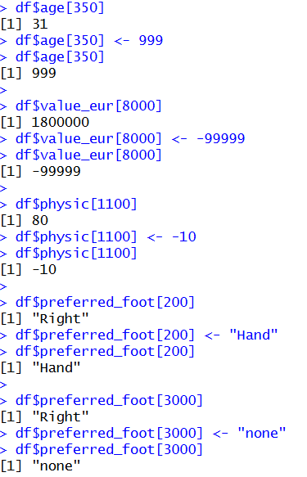

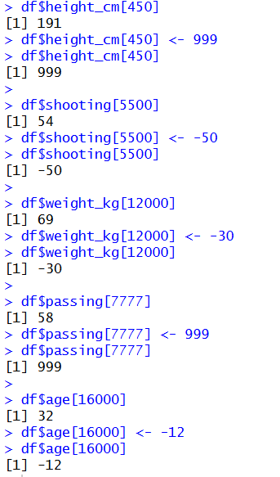

The output shows the original value of each row before it was changed and the new invalid value after it has been changed. In fact, the age of Row 350 was altered to 999 which is not humanly possible as compared to its original realistic value.

- Outliers Inserted

Code:

df$wage_eur[900] <- 9999999
df$value_eur[4500] <- 750000000
df$wage_eur[11000] <- 7500000
df$weight_kg[6600] <- 350
df$potential[2200] <- 250
df$height_cm[14500] <- 15
df$value_eur[17000] <- 650000000

Output:

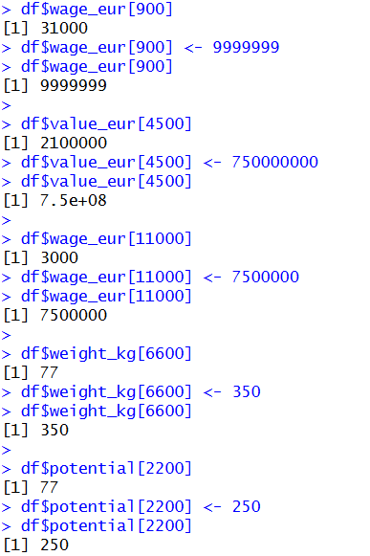

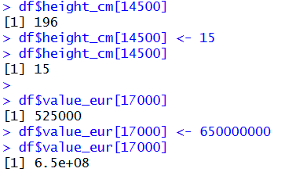

The output shows the original values of each row with the outlier inserted. As an illustration, the weekly wage of Row 900 was overstated to 9,999,999 EUR, which is much higher than any conceivable player salary.

- Duplicate Rows Inserted

Code:

cat("Rows before duplicates:", nrow(df), "\n")
df <- rbind(df, df[10, ])
df <- rbind(df, df[25, ])
df <- rbind(df, df[50, ])
df <- rbind(df, df[130, ])
cat("Rows after duplicates:", nrow(df), "\n")

Output:

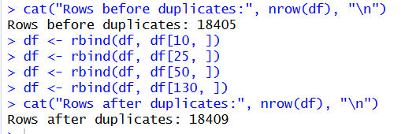

The output shows the row count before and after inserting duplicates. Four exact copies of existing rows (10, 25, 50, and 130) were appended to the end of the dataset, increasing the total row count by 4.

Handling Missing Values:
- Identifying Missing Values

This code uses colSums(is.na()) to count missing values in each column. It helps identify which variables contain NA entries that require cleaning.

Code:

colSums(is.na(df))

Output:

The result contains a numerical number of the number of missing values per column. In the age, height cm, weight kg, overall and potential columns (1 each) five missing values were deliberately inserted. Also, there are about 2062 natural missing values in the pace, shooting, passing, dribbling, defending and physic columns of which they belong to goalkeeper players who lack outfield attribute ratings in FIFA dataset.

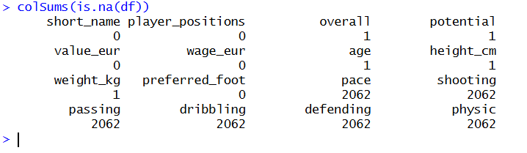
- Graph of Missing Value:
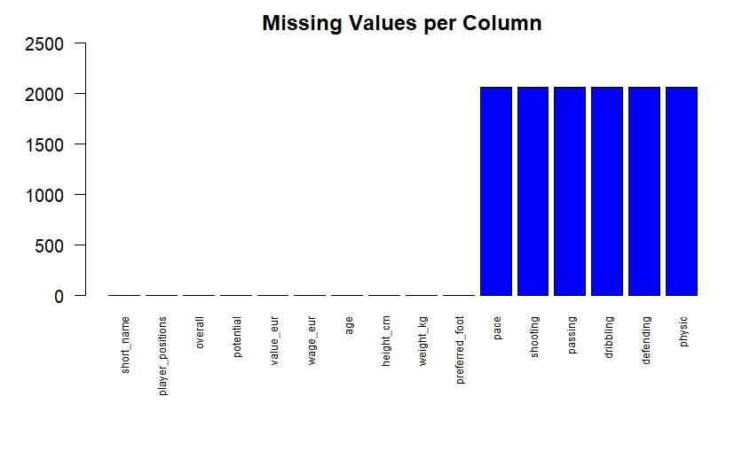
All columns

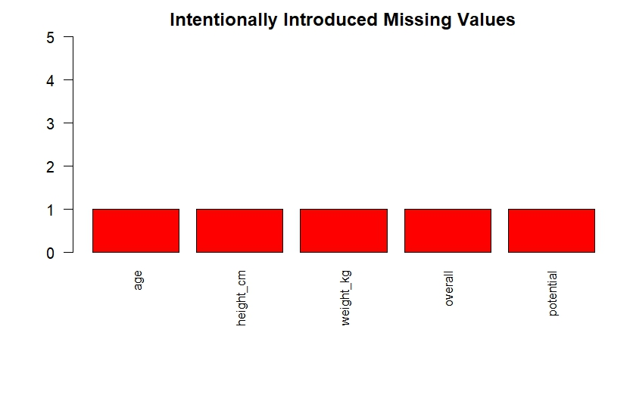
Only intentional missing values

- Replacing Missing Values

Code:

With Mean:

df$age[is.na(df$age)] <- mean(df$age, na.rm = TRUE)
df$height_cm[is.na(df$height_cm)] <- mean(df$height_cm, na.rm = TRUE)
df$weight_kg[is.na(df$weight_kg)] <- mean(df$weight_kg, na.rm = TRUE)
df$overall[is.na(df$overall)] <- mean(df$overall, na.rm = TRUE)
df$potential[is.na(df$potential)] <- mean(df$potential, na.rm = TRUE)

With Median:

df$pace[is.na(df$pace)] <- median(df$pace, na.rm = TRUE)
df$shooting[is.na(df$shooting)] <- median(df$shooting, na.rm = TRUE)
df$passing[is.na(df$passing)] <- median(df$passing, na.rm = TRUE)
df$dribbling[is.na(df$dribbling)] <- median(df$dribbling, na.rm = TRUE)
df$defending[is.na(df$defending)] <- median(df$defending, na.rm = TRUE)
df$physic[is.na(df$physic)] <- median(df$physic, na.rm = TRUE)

Verify:

colSums(is.na(df))

Output:

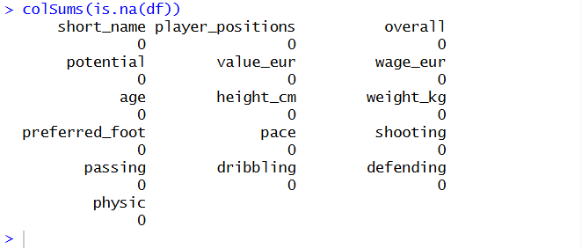

The 5 deliberately added missing values (age, height_cm, weight_kg, overall, potential) were mean imputed as the columns are approximately normally distributed with the mean giving a good central tendency measure. The natural goalkeeper missing values (pace, shooting, passing, dribbling, defending, physic) were imputed with median, as these columns can have skewed distributions, and the median is less susceptible to skewness as it is not affected by extreme values.

Graph After Removing Missing Values:

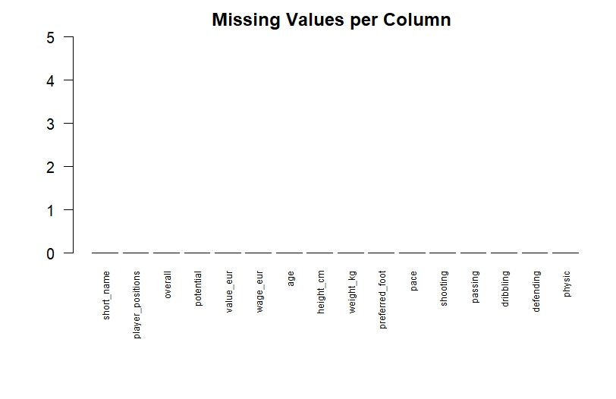

Verifying the changed values:

df$age[100]
df$height_cm[300]
df$weight_kg[400]
df$overall[500]
df$potential[800]

Output:

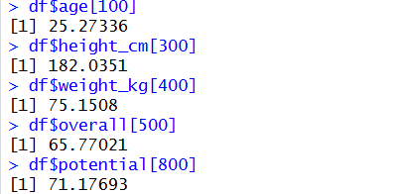

The output shows the imputed values of the 5 deliberately missing rows. Row 100's age was replaced with the mean value 25.27, Row 300's height was replaced with 182.04 cm, Row 400's weight with 75.15 kg, Row 500's overall rating with 65.77, and Row 800's potential with 71.18. These values are the averages of the columns, which proves that the mean imputation was used properly.

Handling Noisy Values:
Noisy values are the ones which are either wrong or unrealistic such as impossible numbers or wrong categories. Noisy values were adjusted by being substituted with a more plausible value. The mode and median were selected in the case of numeric variables since it is not affected by extreme values. The most frequent category (mode) was used in the case of categorical variables.

Code:

df$age[350] <- median(df$age, na.rm = TRUE)
df$age[16000] <- mean(df$age, na.rm = TRUE)
df$value_eur[8000] <- mean(df$value_eur, na.rm = TRUE)
df$physic[1100] <- median(df$physic, na.rm = TRUE)
df$preferred_foot[200] <- "Right"
df$preferred_foot[3000] <- "Left"
df$height_cm[450] <- mean(df$height_cm, na.rm = TRUE)
df$shooting[5500] <- median(df$shooting, na.rm = TRUE)
df$weight_kg[12000] <- mean(df$weight_kg, na.rm = TRUE)
df$passing[7777] <- median(df$passing, na.rm = TRUE)

Output:

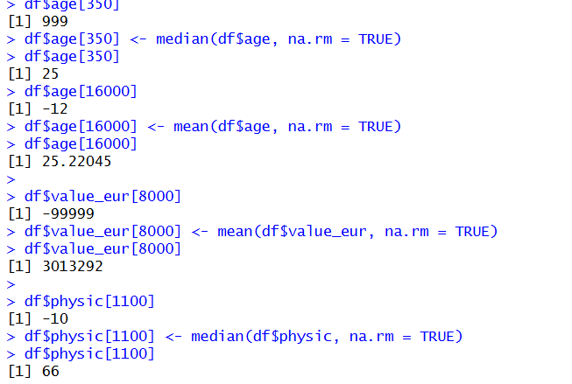

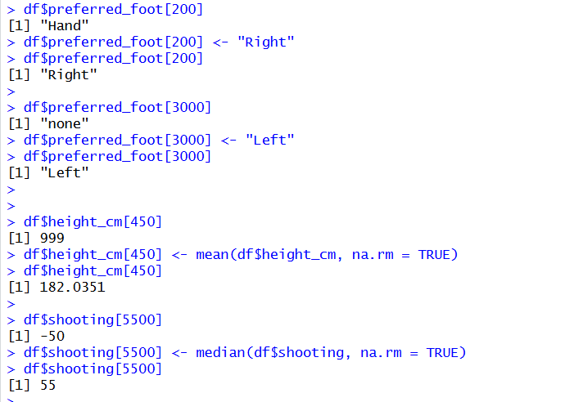

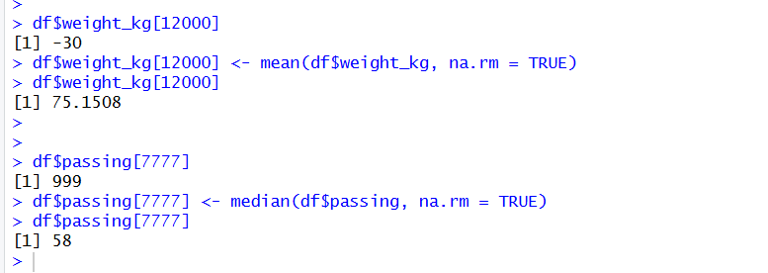

The output indicates that all 10 noisy values were corrected. Invalid numeric values like 999, -12, -99999, -10, -50, -30, and 999 were replaced with either the mean or median of their respective columns. In the case of categorical entries, Hand was changed to Right and none to Left. It was done in three ways, mean when dealing with symmetric columns, median when dealing with skewed columns and mode replacement when dealing with categorical columns.

Handling Outliers:
For wage
Code:

boxplot(df$wage_eur, main = "wage_eur - Before Outlier Handling")
df$wage_eur[900]
df$wage_eur[900] <- median(df$wage_eur, na.rm = TRUE)
df$wage_eur[900]
df$wage_eur[11000]
df$wage_eur[11000] <- median(df$wage_eur, na.rm = TRUE)
df$wage_eur[11000]
boxplot(df$wage_eur, main = "wage_eur - After Outlier Handling")

Output:
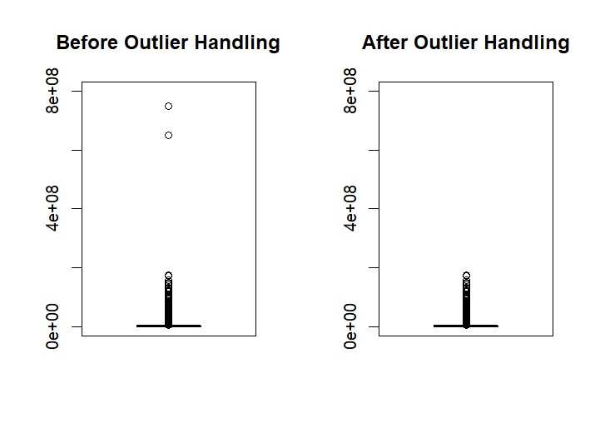

The boxplots depict the value of the eur prior to and after the outliers. The Before plot indicates that the y-axis extends to 600 million EUR because the two extreme outliers (750,000,000 and 650,000, 000) have been carefully placed at row 4500 and 17000. Once these are substituted with the median value, the "After" plot has the y-axis scaled down to a much smaller 150 million EUR.

For Weight:

Code:

par(mfrow = c(1, 2))

df$weight_kg[6600] <- 350
boxplot(df$weight_kg, main = "Before Outlier Handling", col = "red")

df$weight_kg[6600] <- median(df$weight_kg, na.rm = TRUE)
boxplot(df$weight_kg, main = "After Outlier Handling", col = "green")

par(mfrow = c(1, 1))

Output:
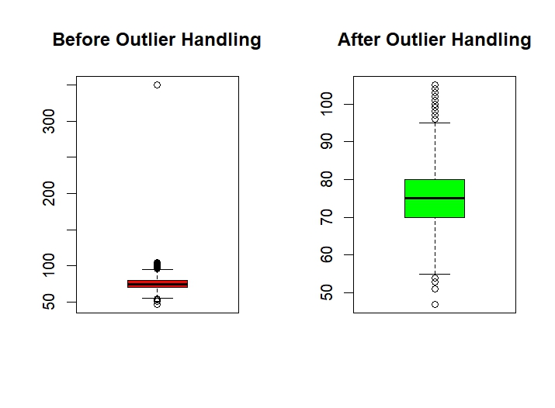

The boxplots reveal the weight kg prior to through outlier handling. The "Before" plot shows the y-axis stretching up to 350 kg due to the intentionally inserted extreme outlier at row 6600. The bottom of the box is compressed and it is hard to see the actual data distribution. Once the outlier has been replaced with the median value, the After plot provides a clear picture of the actual distribution of player weights that lie between about 50 and 100 kg with the median of 75 kg.

Potential outlier:

Code:

dev.off()
par(mfrow = c(1, 2))

df$potential[2200] <- 250
boxplot(df$potential, main = "Before Outlier Handling", col = "red")

df$potential[2200] <- median(df$potential, na.rm = TRUE)
boxplot(df$potential, main = "After Outlier Handling", col = "green")

par(mfrow = c(1, 1))

Output:

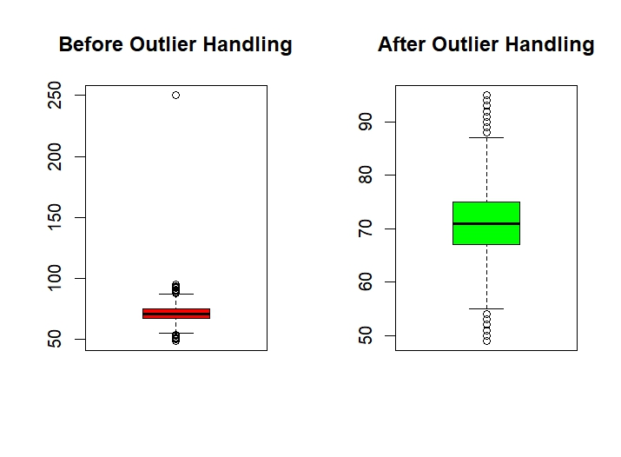

The boxplots show potential before and after outlier handling. The "Before" plot shows the y-axis reaching 250 due to the intentionally inserted outlier at row 2200, which exceeds the maximum possible rating of 99. The box is compressed at the bottom making the distribution unreadable. After replacing the outlier with the median value, the "After" plot reveals the true distribution of player potential ratings, ranging from approximately 50 to 95 with the median around 71.

height_cm outlier:

Code:

dev.off()
par(mfrow = c(1, 2))

df$height_cm[14500] <- 15
boxplot(df$height_cm, main = "Before Outlier Handling", col = "red")

df$height_cm[14500] <- median(df$height_cm, na.rm = TRUE)
boxplot(df$height_cm, main = "After Outlier Handling", col = "green")

par(mfrow = c(1, 1))

Output:

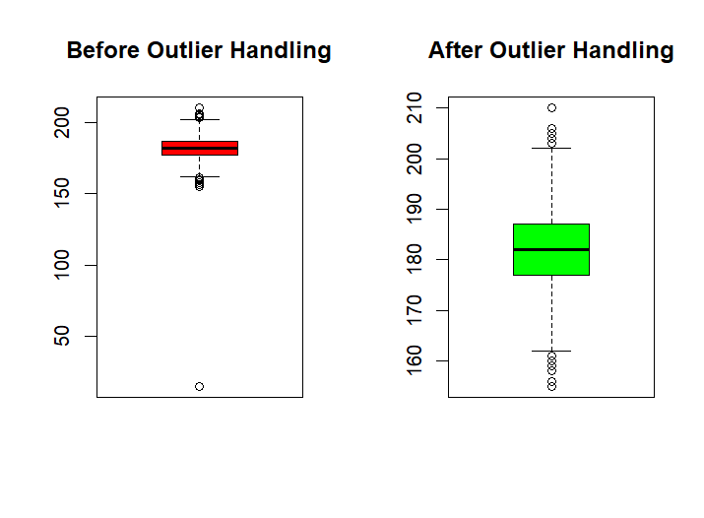

The boxplots show height_cm before and after outlier handling. The "Before" plot shows a single point at the bottom near 15 cm, which is the intentionally inserted unrealistic height at row 14500. This extreme low value stretches the y-axis down to nearly 0, compressing the actual data distribution. After replacing the outlier with the median value, the "After" plot clearly shows the true distribution of player heights, ranging from approximately 160 to 210 cm with the median around 182 cm, which reflects realistic heights for professional football players.

Handling Duplicates:
Code:

cat("Rows before removing duplicates:", nrow(df), "\n")
sum(duplicated(df))

df <- df[!duplicated(df), ]
cat("Rows after removing duplicates:", nrow(df), "\n")
sum(duplicated(df))

Output:

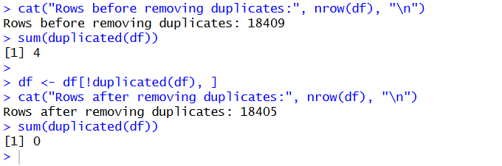

The duplicated() function was used to detect exact duplicate rows in the dataset. Four duplicate rows (copies of rows 10, 25, 50, and 130) were previously inserted intentionally. The sum(duplicated()) function confirmed the presence of duplicate entries. After applying the removal using df[!duplicated(df), ], all duplicate rows were successfully removed. The row count decreased from 18,409 to 18,405, confirming that all 4 intentional duplicates were detected and eliminated.
Normalizing the Dataset:
A min-max normalization function scales selected columns to a 0–1 range: (x - min) / (max - min). The normalized dataset is stored separately to preserve the original.

Code:

normalize_dataset <- df
normalize <- function(x) {return((x - min(x)) / (max(x) - min(x)))}
normalize_dataset$age <- normalize(df$age)
normalize_dataset$overall <- normalize(df$overall)
head(normalize_dataset[, c("short_name", "age", "overall")])

Output:

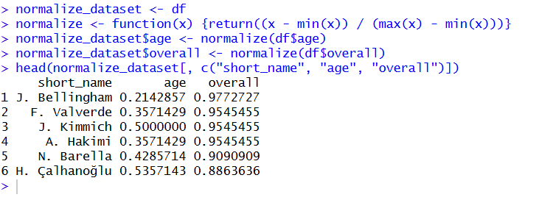

The min-max normalization function was applied to the age and overall columns, transforming their values to a range between 0 and 1. For example, J. Bellingham's age was normalized to 0.21 (indicating he is relatively young) and his overall rating to 0.98 (indicating he is among the highest-rated players). J. Kimmich's age normalized to 0.50 (mid-range) and overall, to 0.95. The normalized dataset was stored separately in normalize_dataset to preserve the original data for further analysis.
Exploratory Data Analysis:
- Summary Statistics:

Code:

summary(df)

Output:

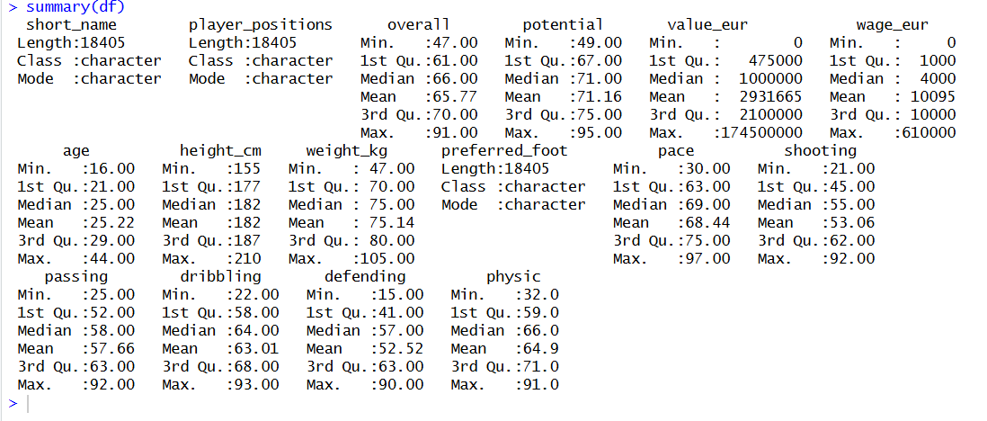

The summary statistics provide an overview of all variable distributions in the cleaned dataset. The overall rating ranges from 47 to 91 with a mean of 65.77, indicating most players are mid-range rated. The potential rating ranges from 49 to 95 with a mean of 71.16, showing players generally have higher potential than their current rating. Player ages range from 16 to 44 years with a median of 25. Market values show significant variation, ranging from 0 to 174.5 million EUR with a mean of approximately 2.93 million EUR, indicating the distribution is heavily right-skewed with a few very high-value players. Weekly wages follow a similar skewed pattern, ranging from 0 to 610,000 EUR. Physical attributes like height (mean 182 cm) and weight (mean 75.14 kg) fall within expected ranges for professional athletes. Skill ratings (pace, shooting, passing, dribbling, defending, physic) all range approximately from 15-97, with means between 52 and 68.

More detailed statistics:

Code:

summary(df$age)
summary(df$overall)

table(df$preferred_foot)

Output:

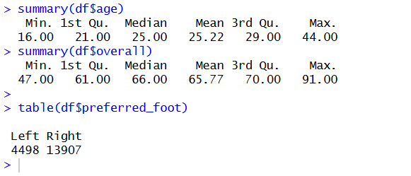

The age of players ranges from 16 to 44 years with a median of 25, indicating the dataset is slightly skewed towards younger players. The overall rating ranges from 47 to 91 with a median of 66 and mean of 65.77, showing most players are clustered in the mid-60s range. The preferred_foot distribution shows a clear dominance of right-footed players (13,907) compared to left-footed players (4,498), which reflects real-world football statistics where approximately 75% of players are right-footed.

Feature Analysis: Detailed Overall Rating Statistics
Code:

cat("Mean Overall:", mean(df$overall), "\n")
cat("Median Overall:", median(df$overall), "\n")
cat("SD Overall:", sd(df$overall), "\n")
cat("Min Overall:", min(df$overall), "\n")
cat("Max Overall:", max(df$overall), "\n")

Output:

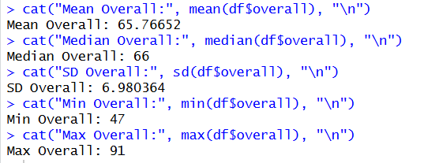

The detailed statistics for the Overall rating reveal that the mean (65.77) and median (66) are very close, suggesting a nearly symmetric distribution. The standard deviation of 6.98 indicates moderate spread around the mean. The minimum rating is 47 and maximum is 91, giving a range of 44 points. Most players fall within one standard deviation of the mean (approximately 59 to 73), which represents the bulk of average-to-good professional players. The top-rated players (85+) represent elite footballers, while the lower end (below 55) represents reserve or youth squad players.
Visualizing Distributions:
- Histogram:

Code:

ggplot(df, aes(overall)) +
geom_histogram(bins = 30, fill = "lightblue") +
ggtitle("Distribution of Overall Rating")

Output:

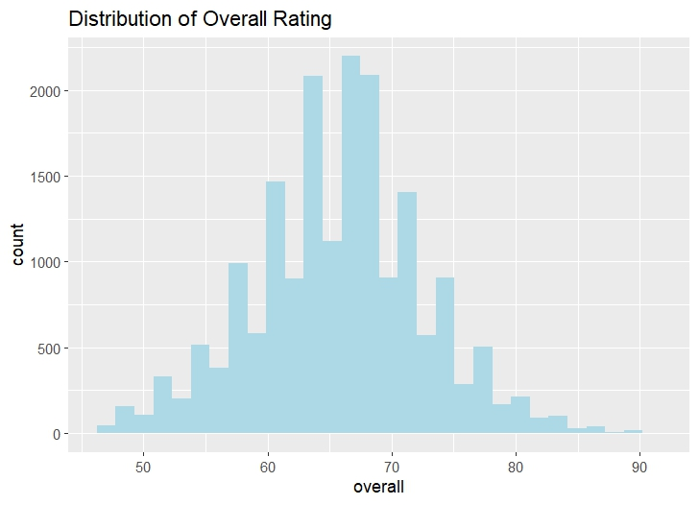

The histogram shows the frequency distribution of the Overall rating. The distribution is approximately bell-shaped with a slight left skew, peaking around 65-68 where over 2000 players are concentrated. The majority of players fall between 58 and 75, representing the mid-tier professional players. The left tail (below 55) contains fewer players representing lower-rated youth or reserve players, while the right tail (above 80) shows very few elite-level players, confirming that top-rated players are rare in the dataset.

- Boxplot:

Code:

ggplot(df, aes(y = overall)) +
geom_boxplot(fill = "lightgreen") +
ggtitle("Boxplot of Overall Rating")

Output:

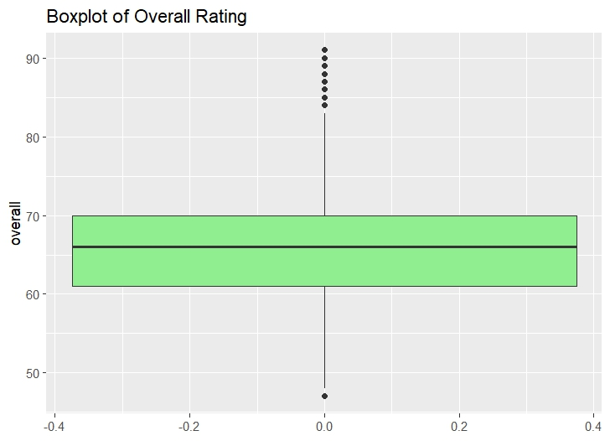

The boxplot displays the spread and distribution of the Overall rating. The median line sits at approximately 66, with the interquartile range (IQR) spanning from 61 (Q1) to 70 (Q3), meaning 50% of all players have ratings between 61 and 70. The lower whisker extends to around 48 and the upper whisker to about 82. The dots above the upper whisker represent outliers — these are elite-level players with ratings above 83 (such as Mbappé, Haaland, Bellingham). The single dot at the bottom represents the lowest-rated player at 47. No extreme artificial outliers remain, confirming the data is clean.

- Density Plot:

Code:

ggplot(df, aes(overall)) +
geom_density(fill = "lightpink") +
ggtitle("Density Plot of Overall Rating")

Output:

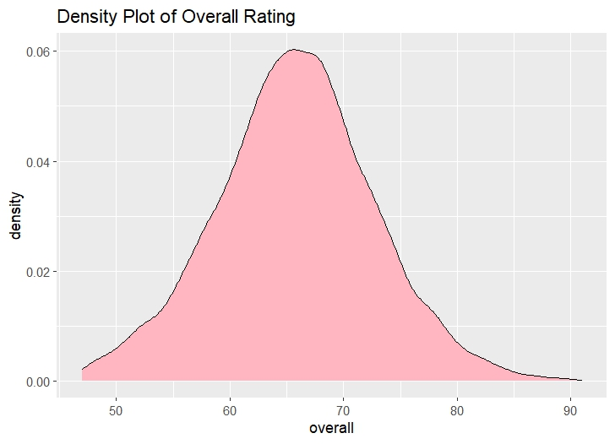

The density plot shows a smoothed probability distribution of the Overall rating. The curve reveals a unimodal (single peak) distribution with the peak around 66-68, confirming that most players are concentrated in this range. The distribution is slightly right-skewed with a longer tail extending towards higher ratings (80-91), indicating that elite players are rare. The left tail drops off more steeply below 50, showing very few extremely low-rated players. The smooth curve confirms an approximately normal distribution with a slight positive skew.

Category Frequency Plot:
Code:

ggplot(df, aes(preferred_foot)) +
geom_bar(fill = "orange") +
ggtitle("Frequency of Preferred Foot")

Output:

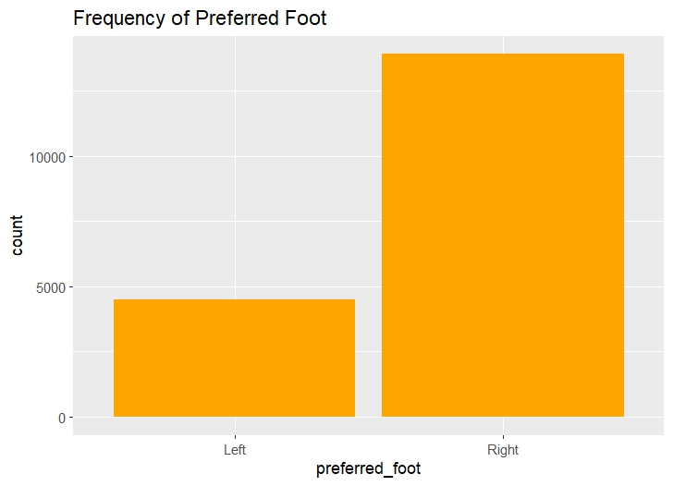

The bar chart displays the frequency distribution of the preferred_foot variable. Right-footed players dominate the dataset with approximately 13,907 players, while left-footed players account for 4,498. This roughly 75%-25% split accurately reflects real-world football demographics, where the majority of professional players are naturally right-footed. The chart also confirms that the two invalid categories ("Ambidextrous" and "none") introduced earlier were successfully cleaned, as only "Left" and "Right" remain.
Group Comparison:
Code:

tapply(df$overall, df$preferred_foot, mean)
tapply(df$overall, df$preferred_foot, sd)

Output:

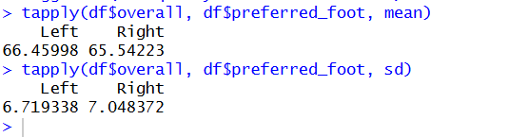

The group comparison reveals that left-footed players have a slightly higher mean overall rating (66.46) compared to right-footed players (65.54), a difference of approximately 0.92 points. The standard deviation is slightly lower for left-footed players (6.72) compared to right-footed players (7.05), indicating that left-footed player ratings are marginally more consistent. This small difference could suggest that left-footed players who make it to professional level tend to be slightly higher rated on average, though the difference is not large enough to draw a strong conclusion.
Descriptive Statistics Across Target Classes (rating_class):
Code:

tapply(df$wage_eur, df$rating_class, mean)
tapply(df$wage_eur, df$rating_class, sd)
tapply(df$age, df$rating_class, mean)

Output:

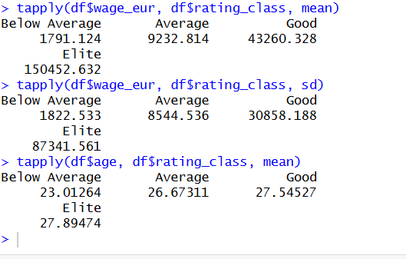

The analysis shows a strong relationship between rating class and wages. Elite players earn an average of 150,453 EUR/week — 84 times more than Below Average players (1,791 EUR). Wage variation also increases with rating class, with Elite players showing the highest standard deviation (87,342 EUR). The mean age increases gradually from 23 (Below Average) to 27.89 (Elite), suggesting higher-rated players tend to be older due to the experience needed to reach peak performance.
Data Filtering::
Code:

data_filtered <- df %>% filter(age > 30)
cat("Players above age 30:", nrow(data_filtered), "\n")
head(data_filtered)

Output:

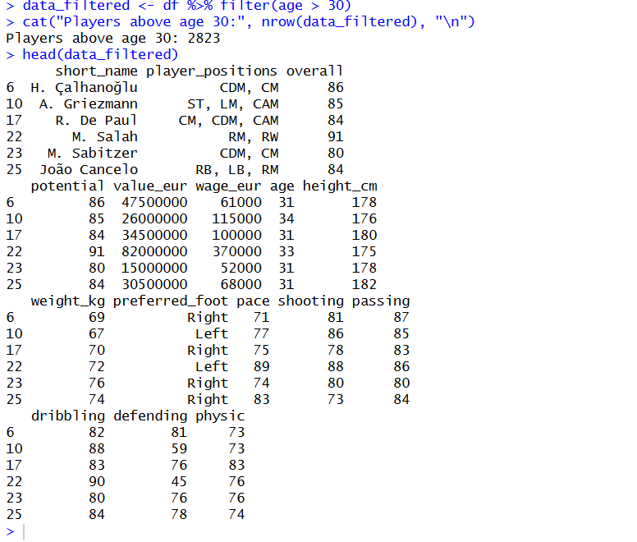

The dataset was filtered to include only players above 30 years of age, resulting in 2,823 players out of 18,405 total (approximately 15.3%). The filtered output shows experienced veteran players like M. Salah (age 33, overall 91), A. Griezmann (age 34, overall 85), and H. Çalhanoğlu (age 31, overall 86). These senior players generally maintain high overall ratings, indicating that experienced professionals can sustain elite performance levels despite advancing age.
Balancing the Dataset:
Creating a categorical target variable based on overall rating:

Code:

df$rating_class <- cut(df$overall,
breaks = c(0, 64, 74, 84, 100),
labels = c("Below Average", "Average", "Good", "Elite"))
idata <- df

Check original class distribution:

Code:

class_dist <- table(idata$rating_class)
class_dist
barplot(table(idata$rating_class), main = "Original Class Distribution", col = "red")

Output:

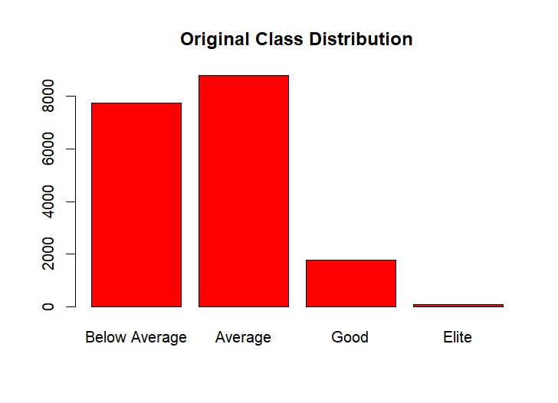
The bar chart and table reveal a highly imbalanced class distribution. The "Average" class (overall 65-74) dominates with 8,792 players, followed by "Below Average" (overall 0-64) with 7,751 players. The "Good" class (overall 75-84) has only 1,767 players, and the "Elite" class (overall 85-100) has just 95 players. This severe imbalance, where the largest class is nearly 93 times bigger than the smallest, could lead to biases in predictive modeling. Balancing techniques will be applied to address this issue..
Balancing Using Over Sampling::
Duplicates minority-class samples to match the majority class size, creating a balanced dataset.

Code:

class_counts <- table(idata$rating_class)
max_count <- max(class_counts)
set.seed(100)
os_list <- lapply(names(class_counts), function(cl) {
df <- filter(idata, rating_class == cl)
if(nrow(df) < max_count) {
df <- df %>% sample_n(max_count, replace = TRUE)
}
df
})

os_balanced_data <- bind_rows(os_list)
table(os_balanced_data$rating_class)
barplot(table(os_balanced_data$rating_class),
main = "Oversampled Category Distribution")

Output:

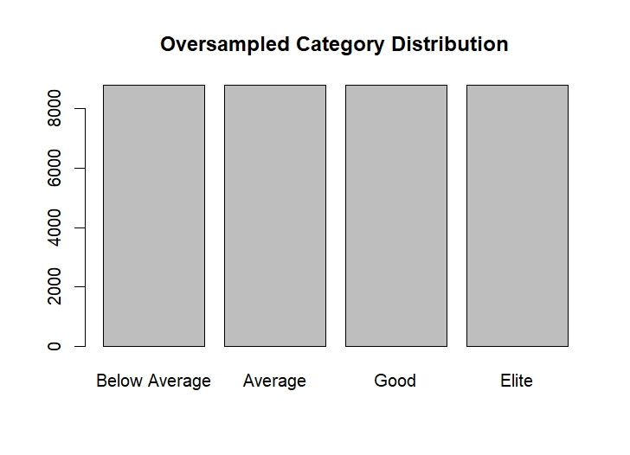

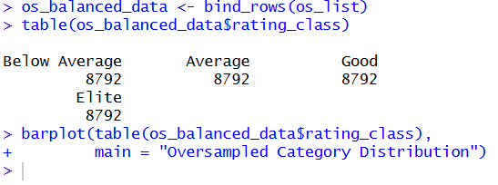

The oversampling technique successfully balanced the dataset by duplicating minority-class samples to match the majority class size of 8,792. All four classes (Below Average, Average, Good, and Elite) now contain equal numbers of 8,792 players each. The "Elite" class, which originally had only 95 players, was oversampled to 8,792 by randomly duplicating existing elite player records with replacement. The barplot confirms that all classes are now evenly distributed, eliminating the class imbalance that could cause bias in predictive modeling.

Splitting the Dataset:
Code:

n <- nrow(df)
random_index <- sample(1:n, size = 0.8*n)
train_data <- df[random_index, ]
test_data <- df[-random_index, ]
cat("Training set rows:", nrow(train_data), "\n")
cat("Testing set rows:", nrow(test_data), "\n")

Output:

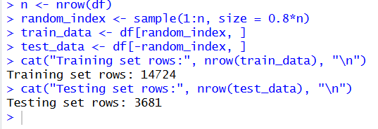

The dataset was split into training and testing sets using an 80/20 ratio. The training set contains 14,724 rows (80%) and the testing set contains 3,681 rows (20%). The rows were randomly selected using the sample() function to ensure an unbiased split. The training set will be used for model building and learning patterns, while the testing set will be reserved for evaluating model performance. This step ensures that the data is divided properly for model training and evaluation.

Conclusion:
In this project, a complete data-science workflow has been implemented on the FC26 FIFA Player Dataset. The raw data was subjected to systematic cleaning in terms of missing values, noisy entries, outliers, duplicated entries, and inconsistent formats. These were indeed crucial preprocessing steps towards making the dataset reliable, consistent, and analytically valid. Following cleaning, the now-refined dataset was subsequently employed for exploratory data analysis, whereby at each instance, descriptive statistics and visualizations provided meaningful insights into the distribution and behavior of key player attributes such as overall rating, potential, age, and wages. Subsequent steps include normalization, filtering, feature exploration, class balancing, and dataset splitting to further prepare data for downstream machine-learning tasks.
In general, the project shows that the structured data-science pipeline matters from raw data to a clean and interpretable form, to analyzing underlying trends, all the way to preparing the data for predictive modeling. The cleaned dataset is now well-organized, sound statistically, and ready for model development to contribute toward understanding and predicting player performance and ratings.

